WHERE DID THEY GO?
Written by Leo Day on the back of the photograph below
Left to Right
Back Row
1. Self [Leonard Osborne Day father] 2. [Harry] Reg[inald Day of Fremantle WA], godfather [Uncle i.e. Leo’s brother]
Front Row
1. Patricia Martha Day Born 19-11-1914
2. Ledah May Day (standing) Born 12-7-1912
3. Tham (mother) with Ethel Kraisee Day (baby) Born 9-7-1920 (6 weeks)
4. Phoebe Eva Day Born 24-10-1916
5. Richard George Day Born 13-8-1911 [maybe adopted or fostered from Tham’s family?]
Herewith the "whole dam family" in Siam
All christened at St Mary's Church Bangkok by the Rev Simmonds on 5-9-1912
Signed Leo Day
Lieut Colonel BK Siam
**********************************
[Note: The christening date cannot be correct as only two of the children were born in 1912. From the age of the baby (6 weeks) we can deduce that the photograph was taken in late August 1920. It is therefore possible that Leonard meant to write 5-9-1920 as the christening date.]

Cemetery Burial Register; Ban Mai, Bangkok, Siam
Page: 25 No. 199
Leo Day of Bangkok, Buried: June 11 1927, Aged: 49 years, Ceremony performed by Cecil R Simmons
Harry drowned during a visit to Bangkok in August 1921 and was buried at Christchurch, Bangkok
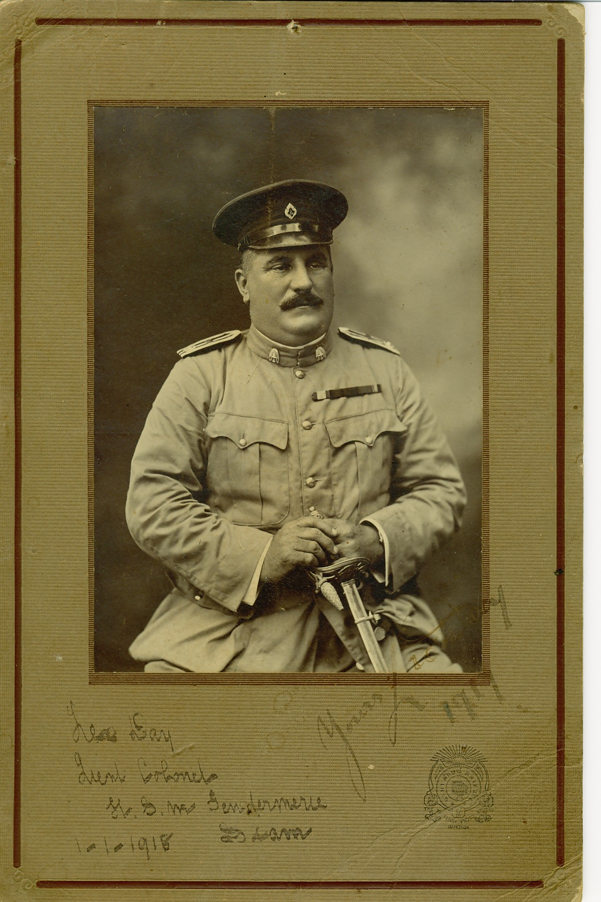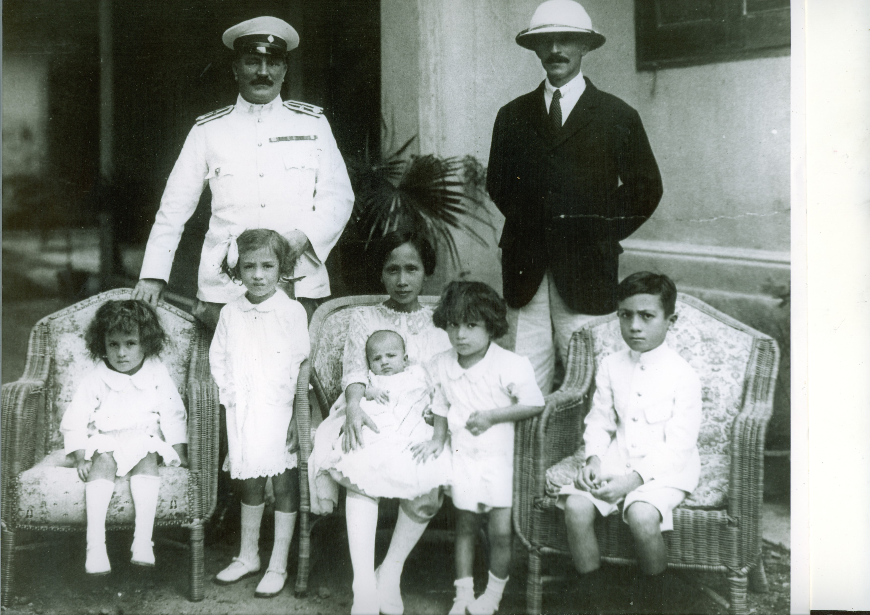
Left: Leo in uniform of Lt Colonel HSM Gendarmarie Siam 1917
Right: With Princess Tham and their children on Christening day, 1920.

